Game Design Document

Fill up the Following document

1. Write the title of your project.

Ans : **Prodeal**

1. What is the goal of the game?

Ans : To have the maximum number of property and cash at the end of the game.

1. Write a brief story of your game?

Ans : **Prodeal** is a property dealing game, the game will be played between two players. Each player will be given a certain amount of cash from the bank at the beginning of the game. The game has a starting point and the game starts by rolling the dice. Each player will roll the dice and will move the number of tabs displayed on the dice after rolling. The designing of the board is described as below:

1. **Cities**: The player can buy different cities by paying the mentioned amount.
2. **Railway station**: Each time the players land on the station tab, have to pay the mentioned amount.
3. **Tax**: Each time the player lands on the tab, have to pay tax of the mentioned amount.
4. **Reward**: Each time the player lands on the reward tab, gets to collect amount from the bank.
5. **Jackpot**: Each time the player lands on the jackpot tab, have to collect the mentioned amount.
6. **Medical Expense**: Each time the player lands on the medical expense tab, have to pay the mentioned amount.
7. **Stock Market Profit**: Each time the player lands on the Stock Market Profit tab, have to collect the mentioned amount.
8. **Traffic Rules Violation**: Each time the player lands on the Traffic Rules Violation tab, have to pay the mentioned amount.
9. **Restaurant**: Each time the player lands on the Restaurant tab, have to pay the mentioned amount.

The player can build a hotel in a property owned by them with a certain expense. When the other player lands on the cities owned by other player, the player has to pay rent.

At the end of the game, the player having the highest property valuation and cash will *win the deal.*

1. Which are the playing characters of this game?

* Playing characters are the ones which respond to the user based on the input from the user
* Cars, monkeys, dinos, wizards etc, are the playing characters in the game.

|  |  |  |
| --- | --- | --- |
| Number | Character Name | What can this character do? |
| 1 | Player Disc’s | It will move to the places number of places as shown in the dice. |
| 2 |  |  |

1. Which are the Non Playing Characters of this game?

* Non Playing characters are the ones which don't have an action or a behavior when the user interacts with the game.
* Hurdles, stones, bananas, coins, etc are non playing characters in the game.

|  |  |  |
| --- | --- | --- |
| Number | Character Name | What can this character do? |
| 1 | Dice | It will show the Disc’s how many tabs to move. |
| 2 | Hotels | They are props which can be bought. |
| 3 |  |  |

1. Draw your imagination of this game. What does this game look like?

* Draw the game either on your computer or on paper,
* Add images of scenes of the game to show each of the playing and non-playing characters at least once.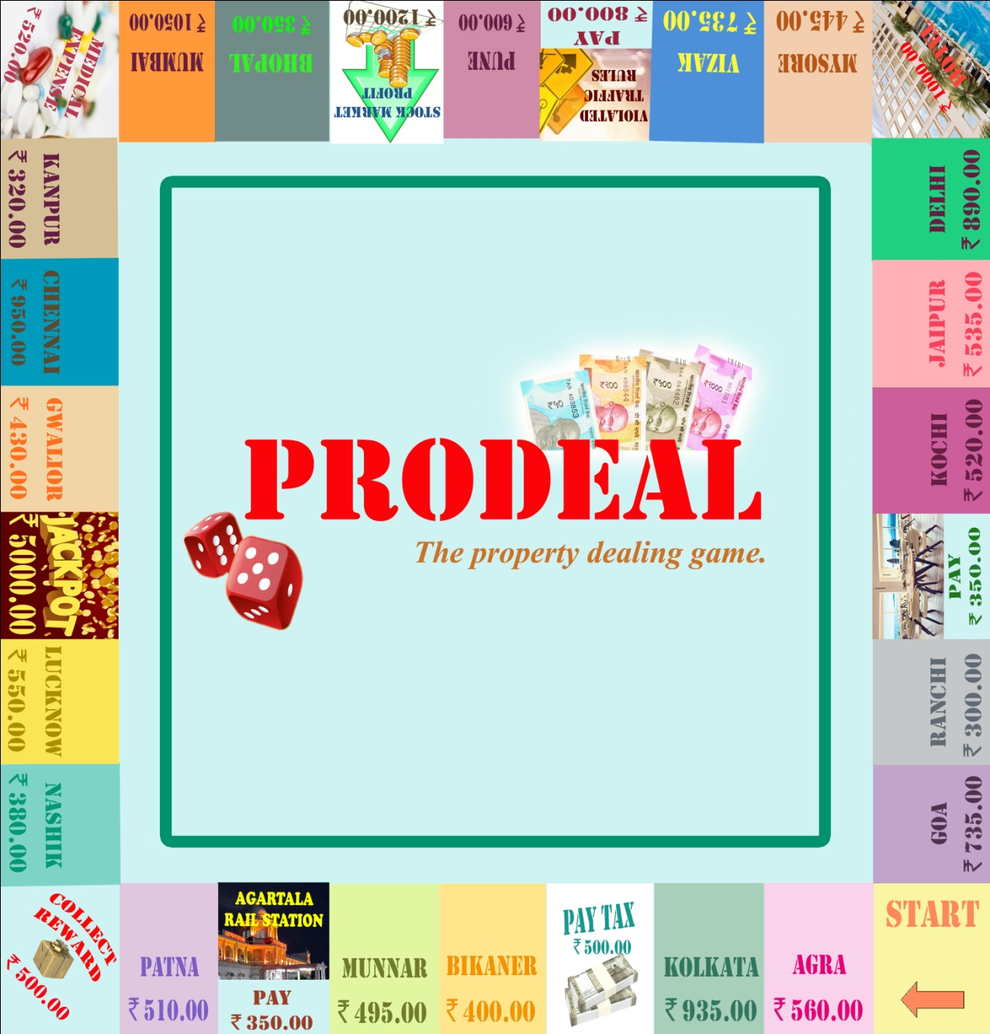

1. How do you plan to make your game engaging?

Ans: The zeal for making more and more property and cash.